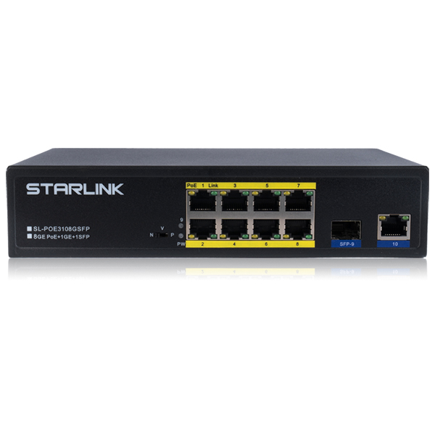
SL-POE3108GSFP

Key Features
- IEEE802.3af/at PoE Standard compatible
- Automatic detection and protection of Non-Standard Ethernet terminals
- 2Port Gigabit Uplink Port
- Save up to 83% Power Green Technology
Specifications
Model | SL-POE3108GSFP
Interface | 8x 10/100/1000T PoE
 | 1x Gigabit RJ45 Port, 1x 1GE SFP Port
Standards | 802.3 10Base-T
 | 802.3u 100Base-T
 | 802.3ab 1000Base-T
 | 802.3x flow control
 | 802.3z 1000Base-X
 | 802.3af/at Power ethernet compliant
Bandwidth | 20Gbps
Mac address | 8K MAC
PoE config | Support Per Port Max 30W
 | PoE Power Max. 130W
 | 1/2(+), 3/6(-) Endspan
Dimension | 210(W) x 140(D) x 45(H)mm
Working environment | Working Temperature: 0~40℃
 | Storing Temperature: -20 ~ 55℃
 | Humidity: 10~90% (No condenser)
Input Power | 100~ 240VAC 50/60Hz,
Power consumption | Max 150W
Warranty | 3years (1년무상, 2년유상)

