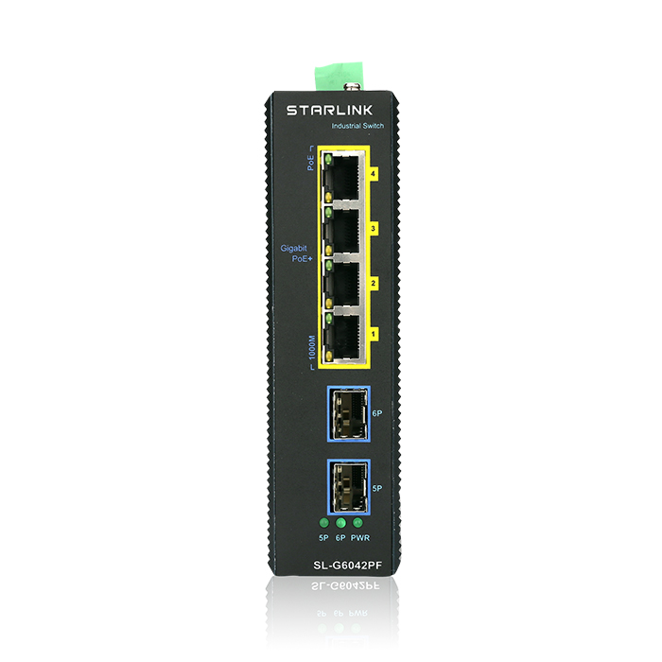

Key Features
- Compatible IEEE802.3af/at PoE+ 30W
- Automatic detection and protection of Non-Standard Ethernet terminals
- IP30 Protection Class, DIN35 rail Mounting
- Industrial design protection grade 4, -40 to 75 ° C operating temperature
Specifications
Model | SL-G6042PF
Interface | 4x 10/100/1000T PoE
 | 2x 1GE SFP Port
Standards | 802.3 10Base-T
 | 802.3u 100Base-T
 | 802.3ab 1000Base-T
 | 802.3x flow control
 | 802.3z 1000Base-X
 | 802.3af/at Power ethernet compliant
Bandwidth | 12Gbps
Mac address | 2K MAC
PoE Spec | PoE Standard IEEE802.3af/at
 | Per Port Max 30W
 | Power pin : 1/2(+),3/6(-)
Industry standard | EN61000-4-2(ESD)
 | EN61000-4-4(EFT)
 | EN61000-4-5(Surge)
 | IEC60068-2-27(shock)
 | IEC60068-2-32(free fall)
 | IEC60068-2-6(vibration)
Dimension | 280(W) x 180(D) x 44(H)mm
Working environment | Working Temperature: -40~75° C
 | Storing Temperature: -40 ~ 85° C
 | Humidity: 5~95% (No condenser)
Input Power | DC48~55V / 3pin terminal block,
Power consumption | Max 150W
Warranty | 3years (1년무상, 2년유상)

