Fiber optic Media converter

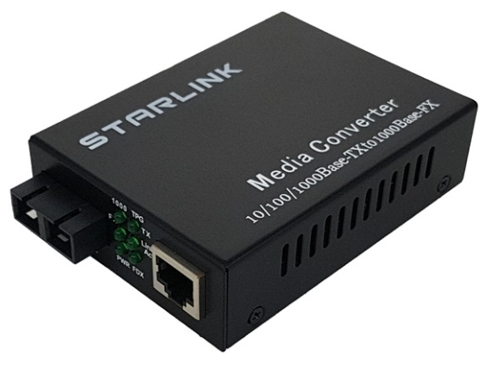

Key Features
- Supported 10/100/1000Base-T Ethernet
- 케이블 MDI/MDI-X 자동감지
- Flow control 지원
Specifications
Model | SL-G2000TS | SL-G2000TL
Interface | 1x 10/100/1000Mbps RJ45 Port
 | 1x 1Gb SC type Fiber Optic Port
Standards | IEEE802.3 10Base-T
 | IEEE802.3u 100Base-T
 | IEEE802.3ab 1000BASE-T
 | IEEE802.3z 1000BASE-FX
Wavelength | 850nm / Multimode | 1310nm / Singlemode
Distance | 224M(62.um) / 550M(50um) | 20KM
Fiber Connector | SC Duplex
Dimension | 26(H) x 70(W) x 94(D)mm
Working environment | Working Temperature: -0~50℃
 | Storing Temperature: -10 ~ 50℃
 | Humidity: 10~90% (No condenser)
Input Power | DC5V 1A
Warranty | 3years (1년무상, 2년유상)

Order info
SL-G2000TL | 10/100/1000Base-T to 1000Base-FX Duplex Singlemode Media converter
SL-G2000TS | 10/100/1000Base-T to 1000Base-FX Duplex Multimode Media Converter

